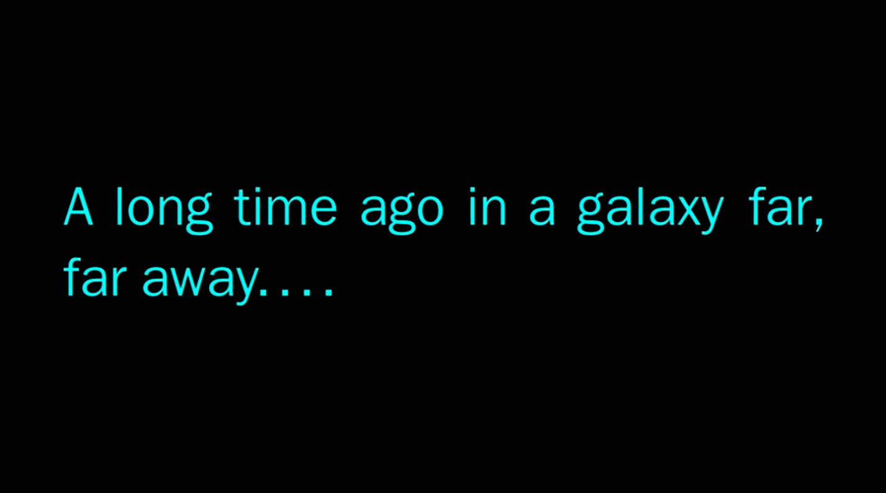
Knights of the Old Republic

Act I
The Search Continues

It is a rare time of peace in the GALACTIC REPUBLIC. Since the near complete extermination of the jedi during the DARK WARS, there has been no credible threat from the Sith or Mandalorians in a decade.

Grand Master Vima Sunrider has resigned from the Jedi Council and is replaced by MICAL of the Lost Jedi. He makes his first priority to gather force sensitive beings to train in the ways of the Jedi.

Using the talents of the existing JEDI KNIGHTS and Republic allies, the Jedi Order fans out across the galaxy, searching for those touched by the Force and ready to begin their journey…

